Hugo Tanaka
CSCI 611
Professor Bo Shen
2026 March 20th
Findings from the hyper-parameters in VGG19
When I was editing around the hyper-parameters in the VGG19 here were my findings with these default configurations:
- content: SF.jpg
- style: goth.jpg
- max_size: 256
- steps: 1000
- alpha: 1.0
- beta: 1000000.0
- lr: 0.003
- print_every: 10
- show_every: 200
- device: cuda
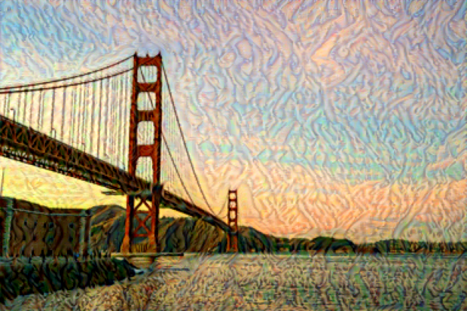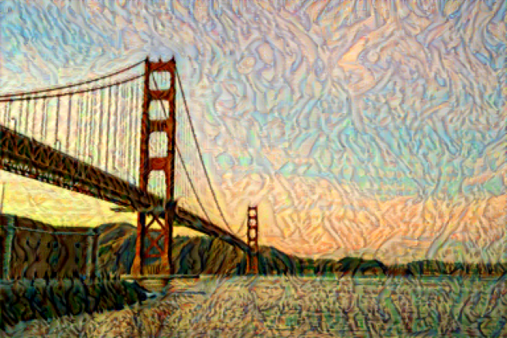
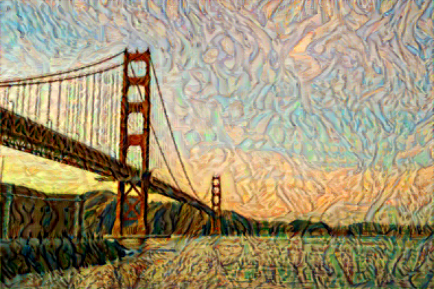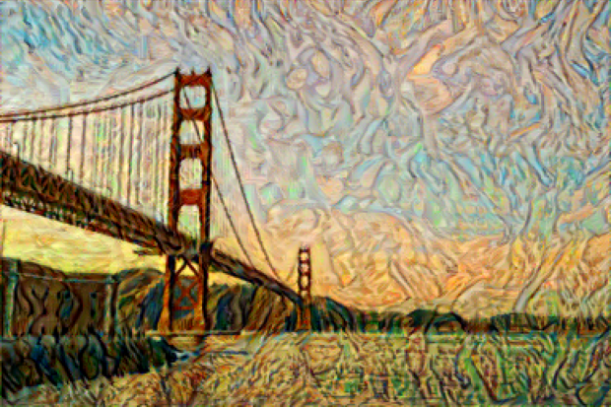
- Top left: 500 steps
- Top right: 1000 steps
- Bottom left: 2000 steps
- Bottom right: 3000 steps
When I ran with different steps, as the steps increased, the output image had more style involved as the steps included. Based on what I see, around 2000 steps is where the image stops growing its style.
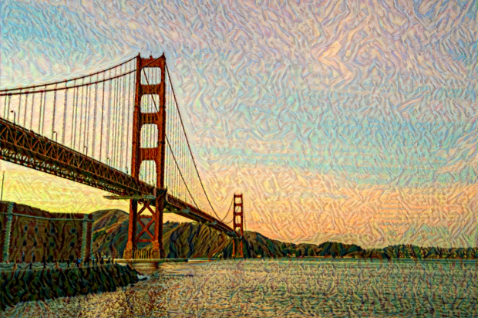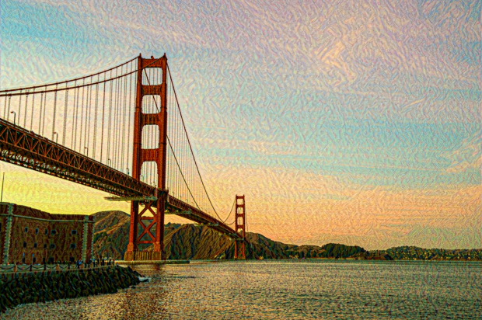
Top-left: (image size) 256
Top right: 512
Bottom left: 1024
Changing the image size makes the size of style; as the image size increases, the output style becomes smaller.
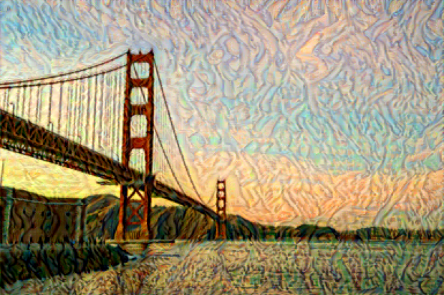
- Left: Alpha = 1
- Right: 10
Changing the alpha value did not change much.
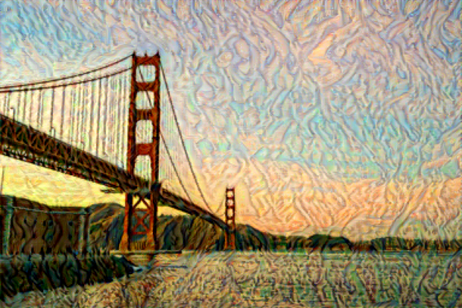
- Left: Beta: 1000000.0
- Right: 10000000.0
Changing the beta did made the style more vivid in output image but not much as changing the step size.

